Ref. No. JSSA/ML/02202933

Memorandum Of Understanding Cum Agreement
This MOU cum agreement is being done on 17/11/25 between JAN SWASTHYA SAHAYATA ABHIYAN (A project of Healthcare Research and Development Board organized under NAC which is registered under companies act 2013 (section 8) Reg.No:053083) and selected DISTRICT Manager ANIL SINGH JADAUN S/O(D/O) - NAVAL SINGH JADAUN under JAN SWASTHYA SAHAYATA ABHIYAN with The following conditions

Dear Mr./Mrs.: ANIL SINGH JADAUN S/O(D/O): NAVAL SINGH JADAUN DOB: 17/11/1990
Application No: 20259453430
Employee ID :

The management of the Company congratulates you on your decision to join us. The terms and conditions of employment are as follows:

- Designation/Department: Your designation shall be DISTRICT EXECUTIVE. You shall report to our HR department& email:(joining.jssabhiyan@gmail.com). These may change in the interest of the company, if required within the framework of your designation.

- Commencement: Your period of employment commences After providing training and authorization letter.

- Place of Work: You will be posted in Dausa District (Rajasthan) but the Company reserves the right to transfer or depute you at any time from one to another district, block, panchayat branch office, subsidiary, associate companies or client locations situated anywhere in India or abroad, whether existing or acquired/established later on. Such transfer or deputation will be as per Company’s policies.

- Confirmation: You will be on probation for Three months from the date of appointment. On expiry of the probationary period it is open for the management either to confirm your services or extend your probationary period. Such an extension can be granted for a maximum of 11 months more, The an agreement, however, reserves the right to terminate your services without assigning any reason during the probationary period, or the extended probationary period. However during the probation period, services can be continued without any notice.

- Compensation: For this position, if you meet the monthly target given by the organization, then the initial Income will be from Rs 0 monthly. If you do not meet the monthly target given by the organization, you will get Label% the work you have done for the entire target for that month will be given to you as income for that month Payment is on the basis of wallet recharge through online.

- Benefits: You will be entitled to Medical, LTA as per rules and regulations of the Company which may be in force from time to time and applicable to your category. Any taxes as per rules of the Income Tax Act or any other Government bodies at any time shall apply. The salary structure may change in case of change of Policies of the company.



Information Intimation: Your appointment is based on information supplied by you. If it is found that you have Misrepresented , concealed or given any wrong information about your candidature at the time of your appointment, your services will be liable to be terminated without any notice or compensation.

  - Whenever you change your present / local address for any reason you shall intimate the change to the Company, immediately.

  - Your appointment is subject to your being certified medically fit.

- Non-Disclosure: You are requested to sign the “Non Disclosure Agreement” attached as Appendix ‘B’, which constitutes an integral part of your working conditions and agreements.

- Training: During the course of your employment with the Company, the Company may impart you training for which you would be required to execute a Service and Surety Bond with the Company, assuring the Company of your service for a minimum fixed period. In case of separation from the company on your request, the company shall recover the amount as given in the Surety Bond.

- Leave: In addition to the national holiday, you will be granted 18 casual leave in a year for which you will have to inform your senior officer of organization. If you are absent for 11 consecutive days in a month without notice, your service will be terminated by giving you a notice.

- Separation: In the event that the Company or you decide to part ways, the basic rules governing the completion of this relationship shall be as follows:

General

We welcome you to to our organization’s project Jan Swasthya Sahayata Abhiyan and wish you a successful, long and happy association.

Please sign the duplicate copy of this letter and return the same to us as a token of your acceptance.

With best regards Yours sincerely,
For Jan Swasthya Sahayata Abhiyan,
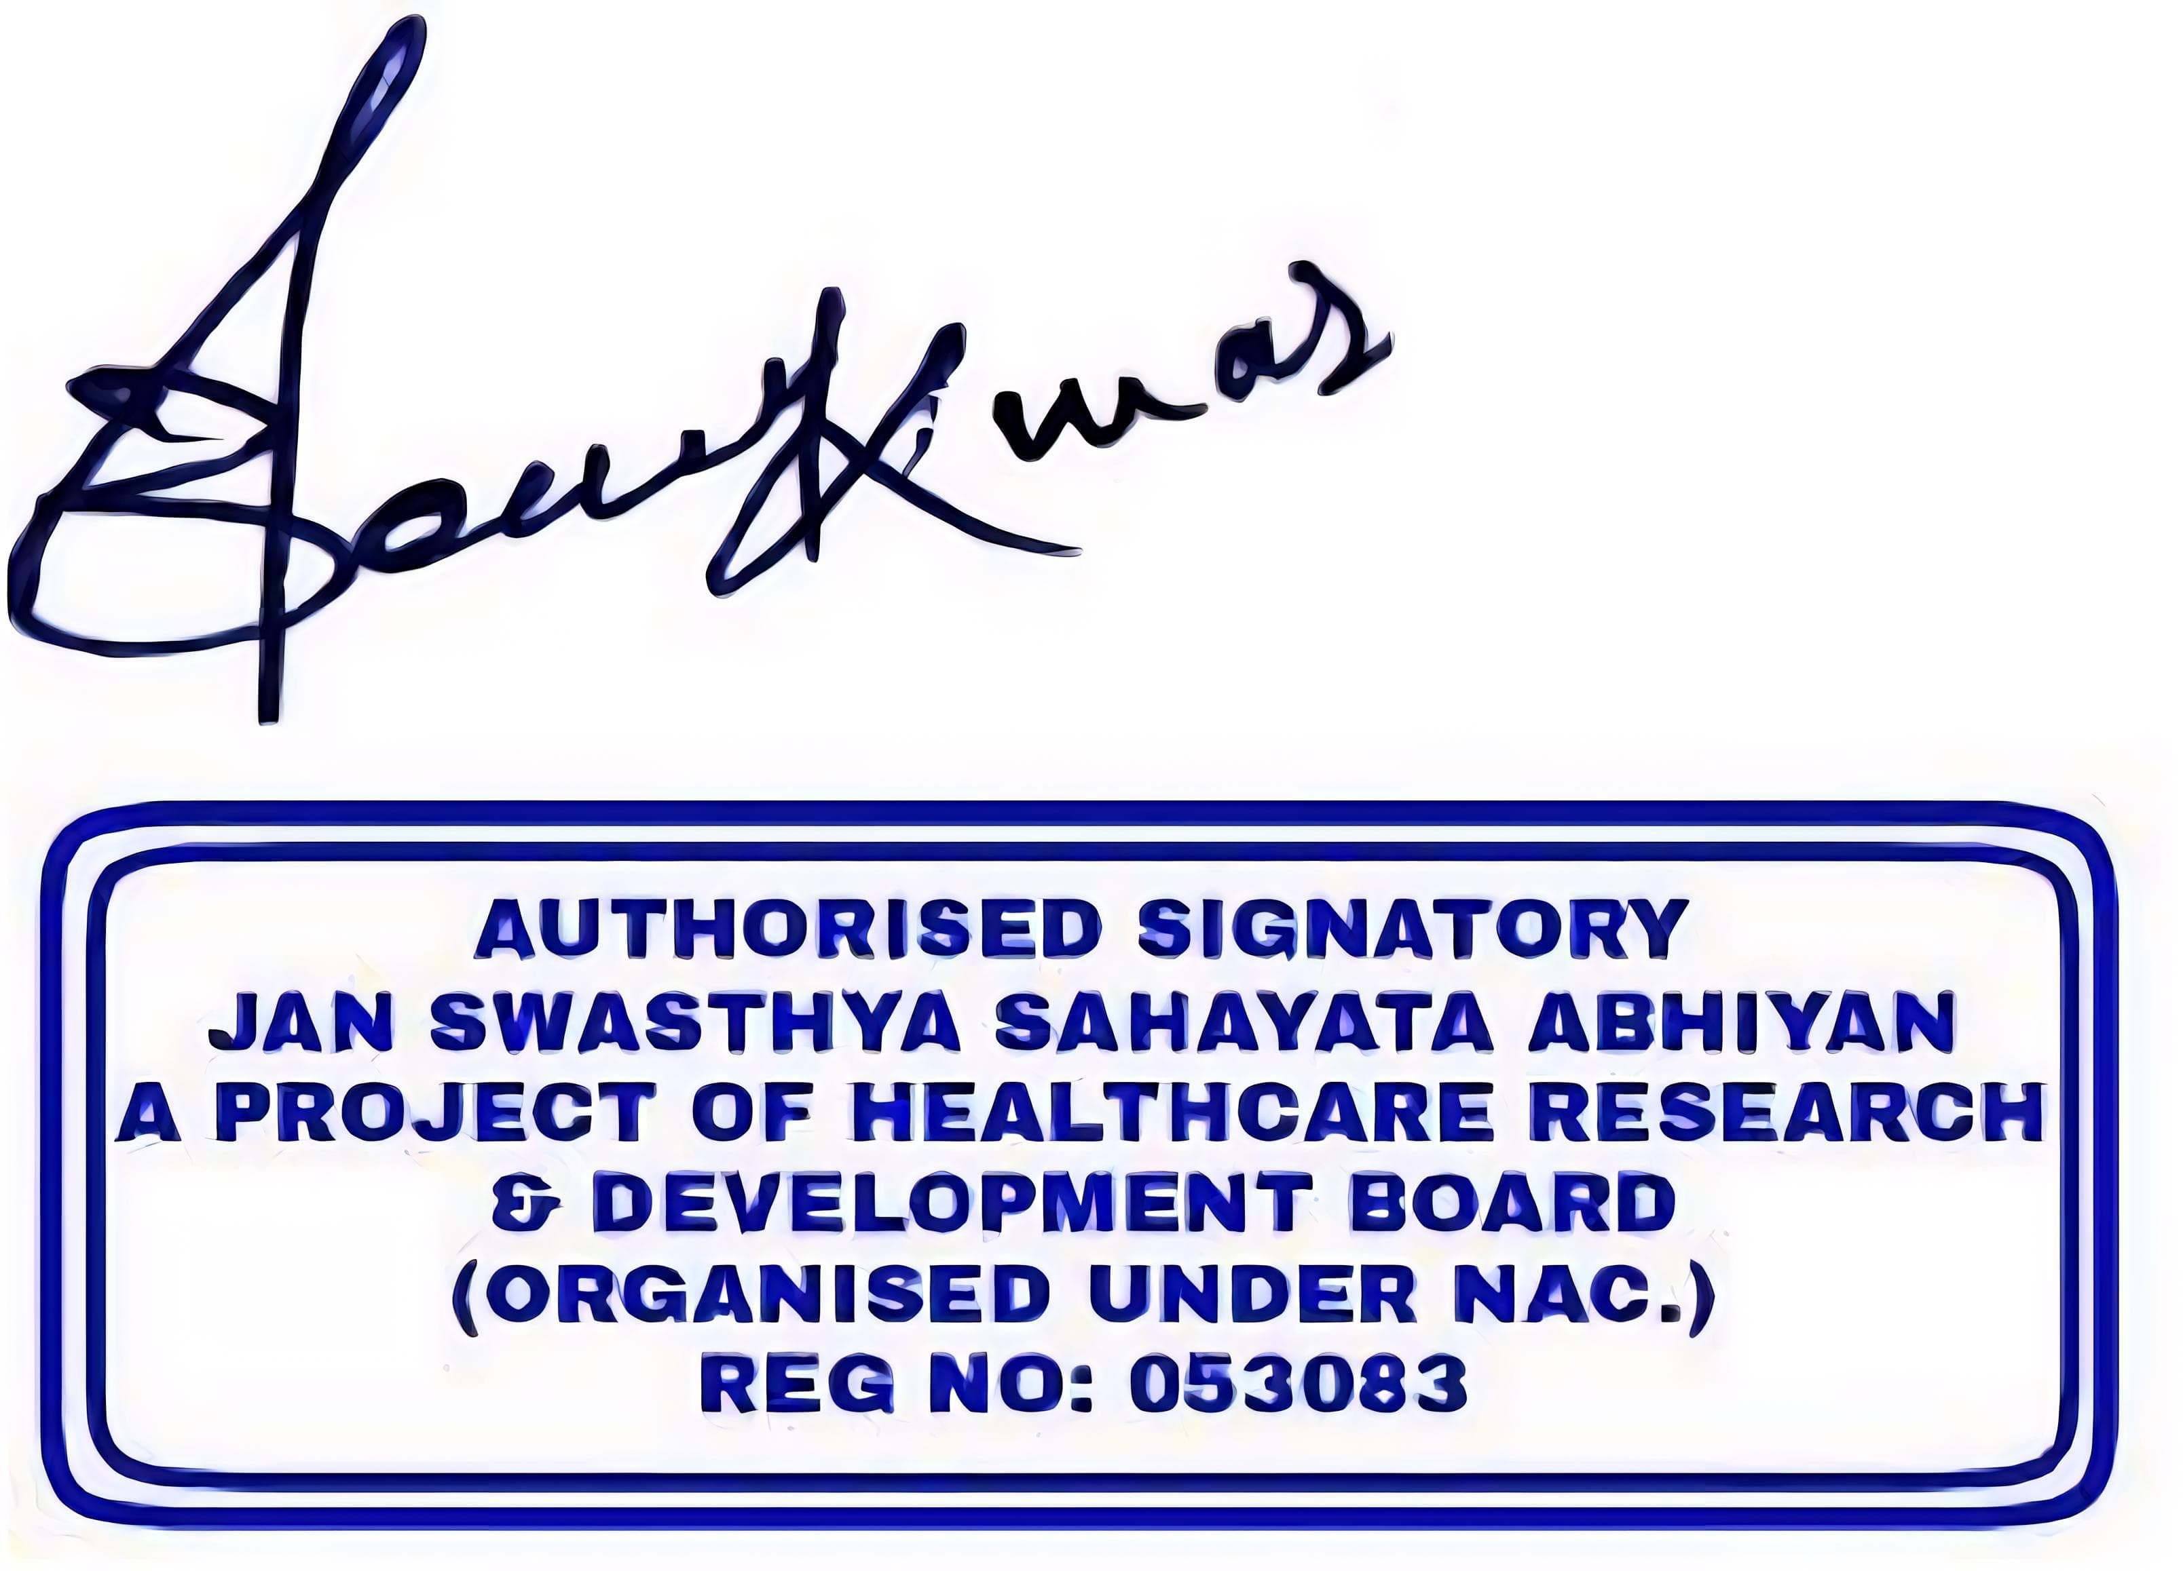
JAN SWASTHYA SAHAYATA ABHIYAN
A project of Healthcare Research and Development (Organized under NAC Reg. No:053083) Registered under Companies Act 2013 under the provision of section 8

I certify that I have read and understood and the contents of the this letter and agree to all the terms and conditions as outlined in the letter.

I certify that this organization is a social service organization that works through contributions and donations, so the application fee, training fee and other expenses fees given by me as a contribution will not be refundable. I am not entitled to take this fee back from the organization.
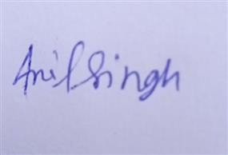
Name: ANIL SINGH JADAUN
Date: 17/11/25

APPENDIX ‘B’

NON-DISCLOSURE AGREEMENT

This Non-Disclosure Agreement (this "Agreement") is entered into this 17/11/25 by and between Jan Swasthya Sahayata Abhiyan (project of Healthcare Research & development Board, organized under NAC which is registered under Companies Act 2013 having its registration number 053083 under the provision of section
8) and ANIL SINGH JADAUN S/O(D/O) NAVAL SINGH JADAUN (Recipient” or “Employee”).

WITNESSETH

WHEREAS Employee has agreed to commence work as an Employee of organization and is signing an Employment Agreement to that effect;
WHEREAS, Employee may be exposed and have access to confidential and/or proprietary information of the Company WHEREAS in order to induce such exposure and access, the parties hereto desire to undertake certain obligations of confidentiality, non-disclosure and non competition as set forth herein;
NOW THEREFORE, in consideration of the mutual undertakings and promises herein, the Recipient hereby agrees as follows:

Definitions

For purposes of this Agreement, the following definitions shall apply:

“Affiliate” shall mean an entity controlled by, controlling or under common control with the Recipient, as used in this definition, the term “control” means the possession, directly or indirectly, of more than 50% of the voting stock of the controlled entity, or the power to direct, or cause the direction of the management and policy of the controlled entity.

“Company” shall include Jan Swasthya Sahayata Abhiyan and any of its Affiliates.

“Development” shall mean any invention, modification, discovery, design, development, improvement, process, software program, work of authorship, documentation, formula, data, technique, know-how, trade secret or intellectual property right whatsoever or any interest therein (whether or not patentable or registerable under copyright, trademark or similar statutes or subject to analogous protection), conceived by Recipient as a result of or in connection with performing the activities, obligations, efforts and / or Services described in the Commercial Agreement.

"Confidential Information" means any and all information and know-how of a private, secret or confidential nature, in whatever form, that relates to the business, financial condition, technology and/or products of Jan Swasthya Sahayata Abhiyan, its Affiliates, customers, potential customers, employees or potential employees, provided or disclosed to the Recipient or which becomes known to the Recipient as a result of the Commercial Agreement, whether or not marked or otherwise designated as “confidential”, “proprietary” or with any other legend indicating its proprietary nature. By way of illustration and not limitation, Confidential Information includes all forms and types of financial, business, technical, or engineering information and know-how, including but not limited to specifications, designs, techniques, methods, compilations, inventions and developments, products, equipment, algorithms, computer programs(whether as source code or object code), marketing and customer, vendor and personal information, projections, plans and reports, and any other data, documentation, or information related thereto, as well as improvements thereof, whether in tangible or intangible form, and whether or not stored, compiled or memorialized in any media or in writing, including information disclosed as a result of any visitation, consultation or information disclosed by Jan Swasthya Sahayata Abhiyan or others on its behalf such as consultants, clients, employees and customers.

"Confidential Information" shall not include information or matter that the Recipient can demonstrate by reasonable and tangible evidence that: (a) was already known to it prior to its disclosure pursuant to this Agreement, or was independently developed by it thereafter without reference to or use of the Confidential Information; (b) have become a part of the public knowledge, without a breach of this Agreement by itself; (c) have been received by it from another person or entity having no confidentiality obligation to jan swasthya sahayata abhiyan or its Affiliates; or (d) is explicitly approved in writing by jan swasthya sahayata abhiyan for release by the recipient. The above Exceptions shall not permit the Recipient to disregard the obligations of confidentiality stated herein merely because individual portion of the Confidential Information may be found within such exceptions or because the Confidential Information is implicitly but not explicitly disclosed in information falling within such exceptions.

Obligations of Confidentiality.

  - Recipient shall treat all Confidential Information disclosed to it as strictly confidential and not to exploit or make use, directly or indirectly, of such Confidential Information without the express written consent of the Company, except for the purpose of performing the activities, obligations, efforts and / or Services pursuant to the Commercial Agreement. Recipient shall assume full responsibility for enforcing this obligation and shall take appropriate measures with its employees to ensure that such persons are bound by a like covenant of secrecy, including but not limited to informing any of its employees receiving such Confidential Information that such Confidential Information shall not be disclosed except as provided herein.

  - Recipient shall not copy or reproduce in any way (including without limitation, store in any computer or electronic system) any Confidential Information for purposes other than the performance of the activities, obligations, efforts and / or Services, without the Company’s prior written consent.

  - Recipient shall refrain from analyzing, reverse-engineering, decompiling, or disassembly or attempting to analyze Confidential Information in order to determine the construction, code, algorithm or topology (composition, formula or specifications) thereof, either by itself or through any third party.
The disclosure of the Confidential Information by the Company shall not grant Recipient any express, implied or other license or rights to patents or trade secrets of the Company or their employees, whether or not patentable, nor shall it constitute or be deemed to create a partnership, joint venture or other undertaking.

  - Recipient shall not remove or otherwise alter any of trademarks or service marks, serial numbers, logos, copyrights, notices or other proprietary notices or indicia, if any, fixed or attached to the confidential Information or any part thereof.

  - If Recipient or anyone to whom Recipient has disclosed the Confidential Information with the consent of the Company is required to disclose any Confidential Information pursuant to the provisions of any applicable law -Recipient shall first notify the Company of such requirement and shall cooperate with the Company so that the Company may seek a protective order or prevent or minimize such disclosure.

  - Recipient hereby assumes full responsibility for any damage caused to the Company as a result of the breach of this Agreement by it or by any of its employees and consultants, and shall take all appropriate measures to insure the non disclosure of the Confidential Information to any third party.

- Return of Proprietary Information: Unless otherwise required by statute or government rule or regulation, upon demand by the Company, Recipient shall: (i) cease using the Confidential Information; (ii) immediately return to the Company all notes, copies and extracts thereof of the Confidential Information, in any form or media whatsoever without retaining copies thereof; and (iii) upon request of the Company, certify in writing that the Recipients have complied with the obligations set forth in this paragraph.

- Intellectual Property Rights. The Recipient hereby acknowledges and agrees that:

The Confidential Information furnished hereunder is and shall remain proprietary to the Company.

  - It shall promptly disclose to the Company, without further compensation or consideration, all Development, and keep accurate records relating to the conception and reduction to practice of all such Development. Such records shall be the sole and exclusive property of the Company, and Recipient shall surrender possession of such records to the Company upon the request of the Company or upon the termination of the activities, obligations, efforts and / or Services of the Commercial Agreement at the latest.

  - It hereby assigns to the Company, without further compensation and consideration, the entire right, title and interest in and to the Development and in and to all proprietary and any and all intellectual property rights therein or based thereon. Recipient shall execute all such assignments, oaths, declarations and other documents as may be prepared by the Company to effect the foregoing.

Non-Solicit.

In addition to any other obligation Recipient may have towards the Company, Recipient agrees that for during the period of the Commercial Agreement and for one (1) year after the termination of the Commercial Agreement for any reason whatsoever, it will not, directly or indirectly:

The Confidential Information furnished hereunder is and shall remain proprietary to the Company.

  - Engage whether as an employee, partner, joint venture, investor, director, consultant or otherwise, in any business activity which is directly or indirectly in competition anywhere in the world, with any of the products or services being developed, marketed, distributed, planned, sold or otherwise provided by the Company during the time of performing the activities, obligations, efforts and / or Services.

  - (i) solicit, induce, recruit, hire or encourage any employee or consultant of the Company to leave such position, or attempt to do any of the foregoing, either for themselves or for any other person or entity,
- contact any customers of the Company for the purpose of selling or marketing to those customers any products or services which are the same as or substantially similar to, or competitive with, the products or services sold and/or provided by the Company in relation to its business at such date, or
- otherwise interfere in any manner with the contractual or employment relationship between the Company and any of its employees, consultants, employees or customers.

Miscellaneous.

  - No failure or delay on the part of the parties to exercise any right, power or remedy under this Agreement shall operate as a waiver thereof, nor shall any single or partial exercise by either of the parties of any rights, powers or remedies. The rights, powers and remedies provided herein are cumulative and are not exclusive of any rights, powers or remedies by law.

  - All notices and requests required or authorized hereunder shall be given in writing either by personal delivery, by registered mail, addressed to the party intended at its address set forth above, or by facsimile, and shall be deemed received as follows: notices served by hand upon delivery, notice served by facsimile the next business day following the delivery, provided however that such notice shall be followed by a telephone confirmation, and notice served by registered mail within seven (7) business days following delivery by registered mail, postage prepaid.

  - This Agreement may be executed in two or more counterparts, each of which shall be deemed an original, but all of which together shall constitute one and the same instrument.

  - This Agreement shall be governed by and construed and enforced in accordance with the laws of

  - India, without regard to the principles of the conflict of laws. The competent courts within the city of Delhi, India, shall have exclusive jurisdiction to adjudicate any dispute arising out of this Agreement. Notwithstanding the foregoing, the Company may resort to any court of competent jurisdiction to obtain injunctive relief to prevent the disclosure of its information.

  - This Agreement shall constitute the entire Agreement between the parties with respect to the confidentiality, non disclosure, proprietary nature of the Confidential Information and shall supersede any and all prior agreements and understandings relating thereto. No change, modification, alteration or addition of or to any provision of this Agreement shall be binding unless in writing and executed by or on behalf of all parties by a duly authorized representative.

  - Recipient may not assign this Agreement without the prior written consent of the Company.

  - The Company may assign this Agreement to any of its Affiliates and/or any entity which is the successor to any part of its business related to this Agreement by way of merger or acquirer of all or substantially all of its assets related to this Agreement and which agrees to assume all obligations of the assigning party under this Agreement from and after the date of such assignment.

  - If any one or more of the terms contained in this Agreement shall for any reason be held to be excessively broad with regard to time, geographic scope or activity, that term shall be construed in a manner to enable it to be enforced to the extent compatible with applicable law. A determination that any term is void or unenforceable shall not affect the validity or enforceability of any other term or condition and any such invalid provision shall be construed and enforced (to the extent possible) in accordance with the original intent of the parties as herein expressed.

  - The Recipient agrees that an impending or existing violation of any provision of this Agreement may cause the Company irreparable injury for which it would have no adequate remedy at law, and agree that the

Company shall be entitled to seek immediate injunctive relief prohibiting such violation, in addition to any other rights and remedies available to it.


IN WITNESS WHEREOF the Employee has executed this Agreement as of the date first written above. EMPLOYEE



Name: ANIL SINGH JADAUN
S/O: NAVAL SINGH JADAUN
Title: DISTRICT Manager
For JAN SWASTHYA SAHAYATA ABHIYAN
HR Department JAN SWASTHYA SAHAYATA ABHIYAN
A project of Healthcare Research and Development (Organized under NAC RegNo:053083)
Registered under Companies Act 2013 under the provision of section 8

